Date: 15 Aug 2016

**Problem List Summary**

Edit

1. Under “Templates”>> “Form Templates”, please add the following functions (see capture below):  
   a) Editing order of existing items;

b) Inserting new item in between existing items;

c) Deleting existing items without affecting other items’ order.

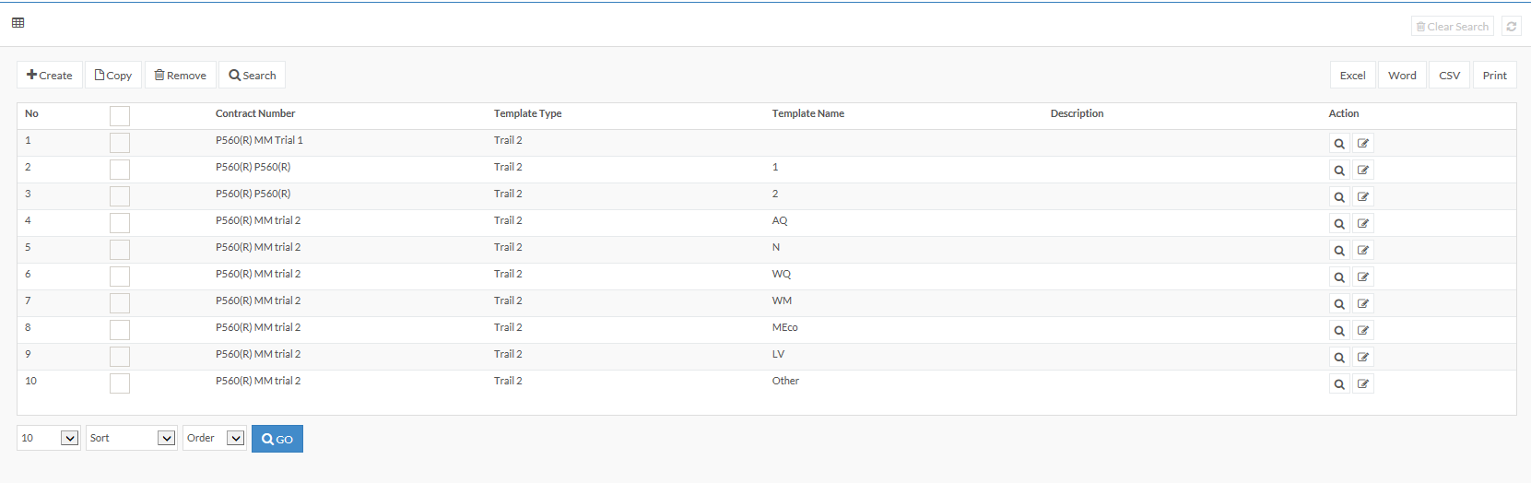

1. Under “Templates”>> “Template Sections”, for editing individual item, please add the following functions (see capture below):

a) Editing order of existing items;

b) Inserting new item in between existing items;

c) Deleting existing items without affecting other items’ order.

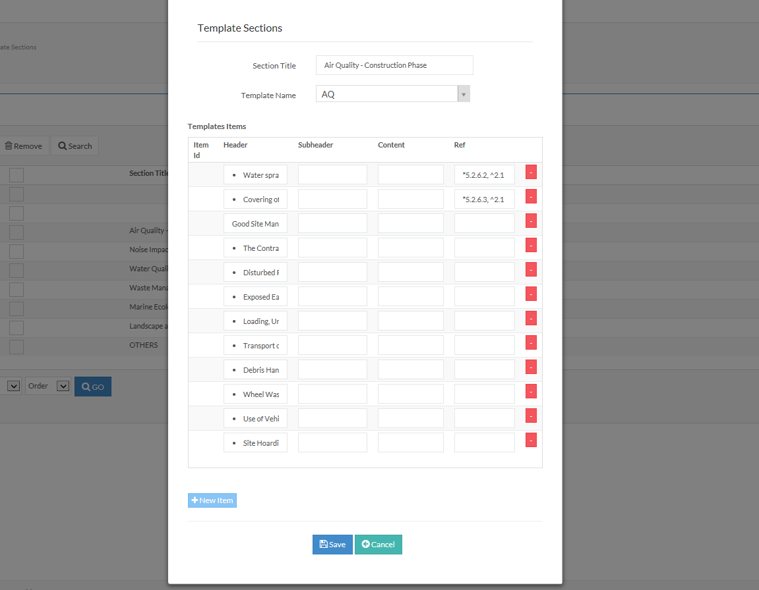

1. Under “Templates”>> “Template Sections”, for editing individual item, the “Subheader” boxes and “Content” boxes seems has no effect in the App’s checklist.

Please add function for distinguishing between **heading** and **subheading**. (e.g. different font, indent, bullet etc.)

(see capture below: ***Air Quality- Construction Phase*** is a **heading**, **Good Site Management** is a **subheading**)

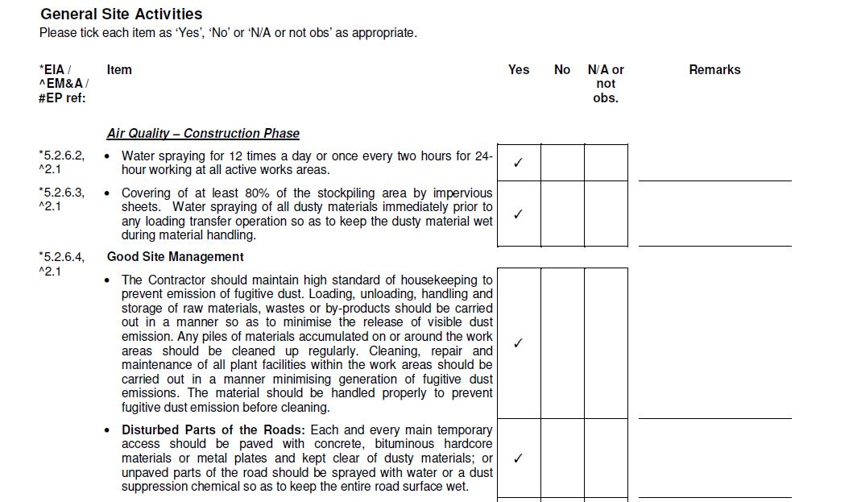

App

1. Since our company logo has changed, please use the new logo for the app.
2. For individual item with remark box, the text inputted in the one remark box will repeat in other remark box in other items.

Please note that there should not be any link in between individual remarks.

1. For photo taking function for individual item, please also allow delete photo function.
2. For the place near the end of the checklist just before the signature place, please add one big text box without heading.
3. For “save and synchronize” button at the end of the form. Please separate “save” and “synchronize” function separately, in case poor internet connection during the field work.
4. For the signature boxes, it is noted that the “save and synchronize” function is not allowing with blank signature boxes. (i.e. with pop up “Please signature PM’s/Contractor/ET/IEC representative first”. However, in real situations, there may not be all four parties available for signature. Please allow the “save and synchronize” function even with some blank signature box.

Submitted Form

1. Please make sure that the output format should stick to the format as our original checklist. It seems there is no output format look like the checklist format so far.
2. Under “Submitted Forms”, neither “Form”, “Forms With Items” or “Form Observation” show information to locate the corresponding items in our checklist. It seems to be difficult to match the individual items shown between the “Submitted Forms” and the original checklist.

It is suggested to add columns like “Section title” or “Ref” to help matching those information shown between “Submitted Forms” and the original checklist.

1. For each “save and synchronize” will generate a list of id (i.e. “Forminfo id” and “Formitem id”) under the “Forms With Items” and “ Form Observation”. However, there is no clear indication correlating those ids to the items in the checklist.

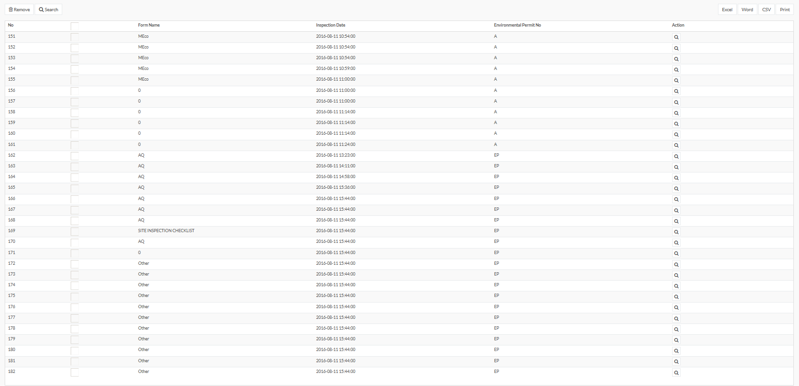

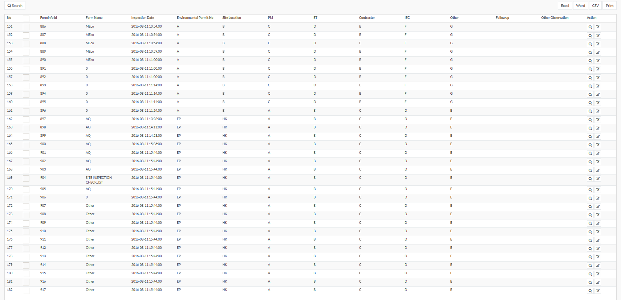

1. Under “Form Observation”, all photos are shown in every item. For each photo, it should be only appeared in the corresponding item but not in all items.

